Marina Allocation Update  April 2021 | 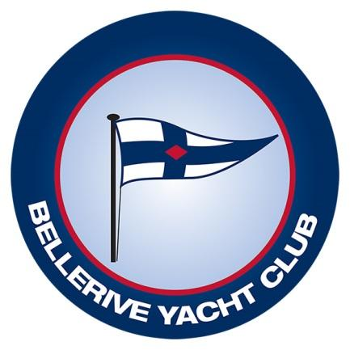
 | Sailing Starts here.

Dear marina berth holder, thanks to all of you who have made submissions on your preferences for a pen in our new marina. We’ve looked at the June 2020 and Feb 2021 surveys and have allocated boats accordingly, with the marina allocation policy as a guideline.
We have done our best to minimise movements to existing berth holders, but we have also made sure that those who have had to move were not disadvantaged. This is why we initially allocated zones rather than initial pens. If you ended up in the same zone as your current pen, we avoided moving you unless you indicated otherwise, but displaced boats were given equal standing for placement before the individual pens were allocated.
Some may still wonder why they were moved though. Those who indicated that manoeuvrability was a concern were moved further out where there is more room to turn. We took the opportunity to have a look at current allocations and where necessary, repositioned them into appropriate size pens. An example is a 10m boat in a 12 m pen, were moved back into a 10m pen. Conversely there are some 10m boats that are too wide for existing 10m pens and were moved to a 12m pen. It may appear inequitable but this was the reason.
We would encourage you to have a look at the new diagram with the individual allocations posted on our website. You will see that some areas are in demand so there isn’t much room to move boats around, but there are some opportunities. We encourage you to discuss allocations with your neighbours and we’d be happy to swap boats if it’s mutually beneficial. We know that there is still some fine tuning to do, and we will be happy to review feedback. There is a new form that you can submit if you would like further consideration.
This will be the final opportunity to have your allocation reviewed by this committee. We will be disbanding at the end of May. There are always boats bought and sold so new opportunities will arise.
Finally I’d like to thank Wayne Freeman, Drew Mienke and Mark Ballard for their tireless work on this project. We placed around 200 boats so far. We appreciated the assistance from our sailing manager Mike Fauve and we feel that his involvement will enable a smooth operational transition, whilst ensuring that the initial placements were done by an independent committee.
All the best…. Jeff Cordell (Chair).

